Assignment 5:
Suyash Damle
15CS10057

The language of the problem statement is slightly ambiguous. Assuming that we are meant to find the correlation between user age-group ratings ( teen or not ) and
The genre of the game being "Action" or not.

PROCESS

First figuring out the correlation between the rating and genre and then working on binary classifications for each type of data to create a differentiation of the following type: Action vs non-Action and T rating vs non-T rating.
The standard function in R is a very convenient and straight – forward way to get the chi-squared test values:

chisq.test (contingency_table)

The p-value output of the standard function denotes the probability that the X² value could be greater than the presently discovered one:
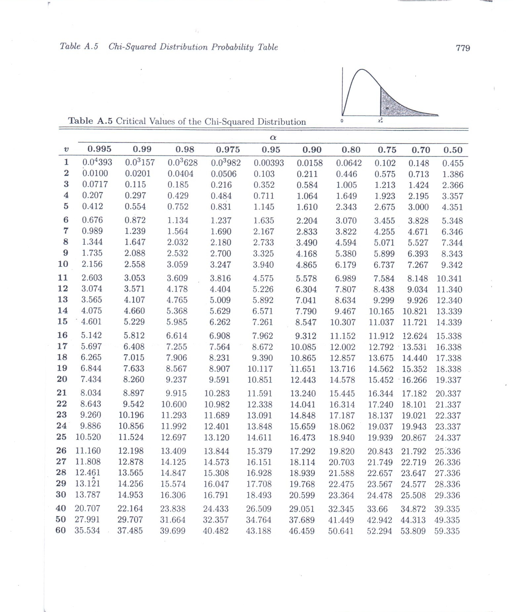

Graph of X² values. Note that the value indicated by ‘α’ in the figure is what is returned as the p - value by the standard r function. Alternatively, this is what we call the ‘significance level’

Hence, we first obtain the contingency table for the whole data and pass it into the function:

The table could be obtained using the table function:

table(Row header,Column header)

Contingency Table:
Strategy Action Adventure Fighting Misc Platform Puzzle Racing Role-Playing Shooter Simulation Sports
AO 1 0 0 0 0 0 0 0 0 0 0 0
E 416 162 8 457 358 289 585 84 48 326 1188 70
E10+ 481 68 19 167 144 43 96 111 58 48 107 78
EC 1 2 0 5 0 0 0 0 0 0 0 0
K-A 0 0 0 1 0 0 0 0 0 0 0 2
M 608 99 49 13 3 0 18 162 565 5 16 25
RP 0 0 0 0 0 0 1 0 0 0 0 2
T 681 115 362 239 64 10 172 420 348 190 198 162

Pearson's Chi-squared test

data: cont_table
X-squared = 5255.7, df = 77, p-value < 2.2e-16

H0 : genre and rating values are unrelated

From the above table, p-value is quite small. This implies that the probability that the X² value could not possibly be any more than the obtained value with the given number of degrees of freedom. Hence, the hypothesis is not rejected – that is, they are possibly related.

Now, working with binarized attributes:

Contingency Table:

new_genre
new_rating Action non-Action

T 681 2280
non-T 1507 5482

Pearson's Chi-squared test

data: bin_cont_table
X-squared = 2.419, df = 1, p-value = 0.1199

From above, the p-value is about 12%. Hence, the probability of X² value being more than 2.419 is 12% . Hence, if we consider a benchmark significance level of 5%, (ie, we need a probability of 5% to reject the independence assumption), this test leads us to reject out H0.

Hence, for the binary division of the two attributes, we get a strong indication of the independence of rating and genre.

Therefore, we conclude that there is sufficient indication that the genre action is not necessarily related to the rating “T” (ie teens).

